1. You will prepare two files for importing the Baseline information. One is an **Activity file** and the other is a **Resource file**.
2. The fields you need for the **Activity File** are Control Account, OBS, Work Package, Description, Baseline Start Date, Baseline Finish Date, and EVT. Add a column between the Description and Baseline Start Date. Title this column “ID”. Copy the Work Package column to the ID column. They are now identical.
3. Your file should be formatted like this: Make sure dates are formatted with a 4-digit year.

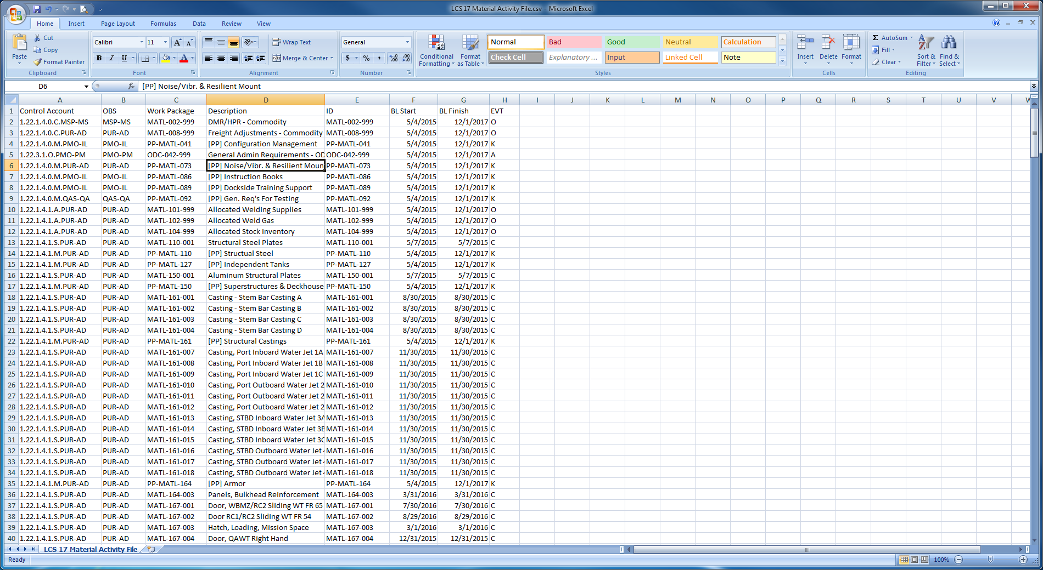

Save this file, you are done with it.

1. The fields you need for the **Resource File** are Work Package and Amount. Insert a column between Work Package and Amount and label this column “Resource”. Enter “MATL” in every cell down the entire column except for the ODC activities. Enter “ODC” as the resource for those Work Packages. Label the first three available columns to the right “Start”, “Finish”, and “Class”. Select the Amount column and format as a number **without** the comma separator. In the Class column, enter “Budget” all the way down the column.
2. Your file should be formatted like this: Make sure dates are formatted with a 4-digit year.

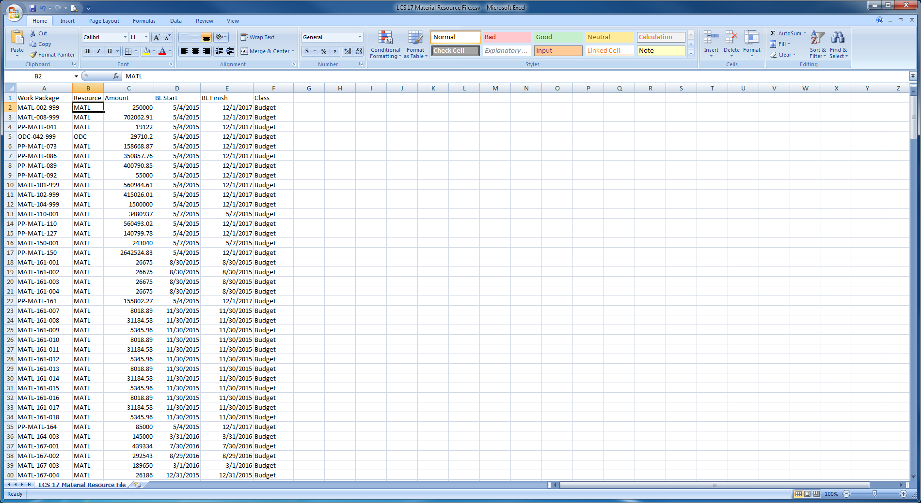

Save this file, you are done with it.

1. In Cobra, start the Integration Wizard. Select Project Data. Click Next.
2. Select the radio button to Open an existing configuration. Navigate to and select your Baseline load file. Click Next.
3. Check the boxes for Control Account and Work Package, and Resource Assignments. Click Next.
4. Click the ellipsis for Activity File, navigate to and select the Activity file you just created.
5. Click the ellipsis for Resource Assignment File, navigate to and select the Resource file you just created.
6. Select your project. Click Next.
7. The field mapper should already be set with the order of the fields in the Activity File. Click Next.
8. Click Next on the Earned Value screen.
9. The Resource Assignments screen should look as follows: Click Next.

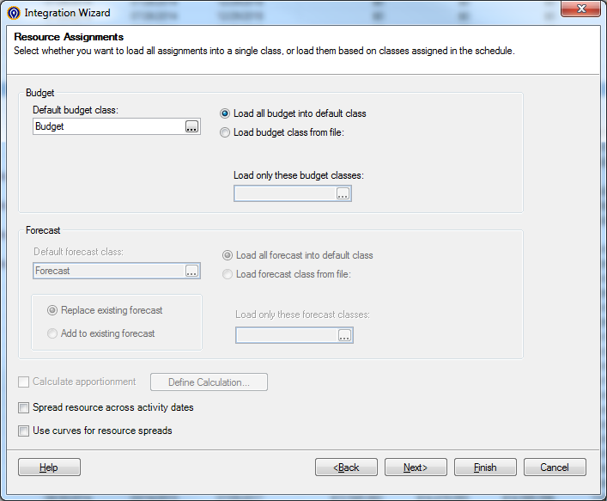

1. The Change Control screen should look as follows: Click Next.

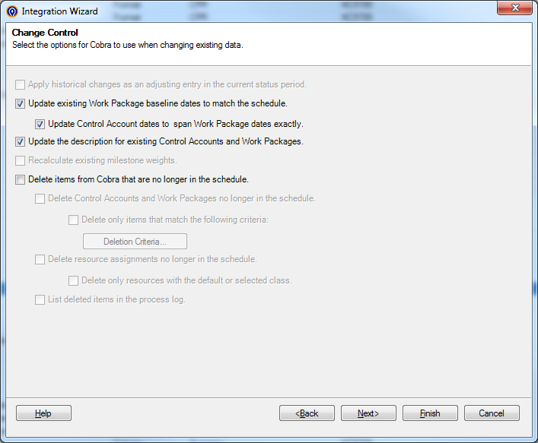

1. On the filter screen, select Total Project as the criteria. Click Next.

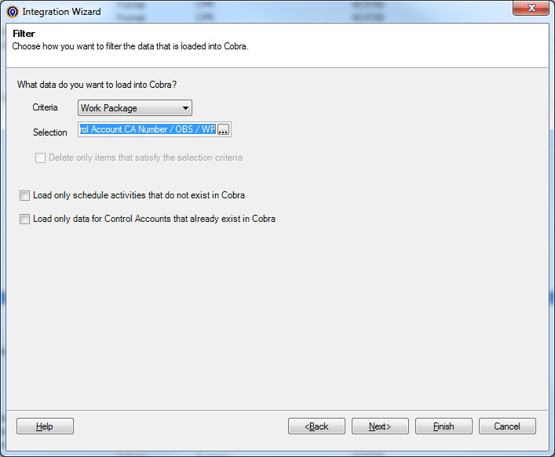

1. Don’t check the box to load resource codes as non-significant. Click Next.
2. Save if you want, otherwise click Finish.